Examining Wild Bird Feeder Color Preferences in Illinois

Jeanette C. Shutay

Miami Ohio University

**Abstract**

The purpose of this experimental research study was to examine wild bird preferences in Homer Glen, IL to determine if such birds show a preference for green backyard feeders over yellow backyard feeders. The research hypothesis for this study was that wild birds in Homer Glen, IL will prefer green feeders over yellow feeders. The bird feeders were filled at various times of the day and then examined at various increments of time to determine the amount of food consumed in each feeder, and a calibration curve was constructed to determine the rate of consumption in grams. Since the location of the feeders was not constant (one location had more cover and was less conspicuous than the other), the feeders were rotated each time a measurement was taken to balance out any potential effects of the location on the dependent variable. The results of this study indicate that the research hypothesis was not supported given that no significant difference was found between the rate of consumption in grams between the green and yellow feeders, although a trend was found in that birds preferred less cover. Future research should examine bird preferences for less cover, the extent to which impacts of cover on consumption may be explained by other factors (e.g., availability or visibility of the feeder), and the impact of wild bird feeding on the demography of other organisms in the region.

**Introduction**

Human-animal interaction has the potential to create both positive and negative impacts on those engaged in the interaction. With wild bird feeding, potential benefits to humans include becoming more relaxed (lower stress) and feeling a greater connection to nature (Cox, & Gaston, 2016; Martin & Greig, 2019). In addition, wild birds benefit from backyard bird feeders by experiencing population increases despite decades of declines, particularly in agricultural locations (Pierret & Jiguet, 2018). In fact, long-term garden or backyard bird feeding has been found to impact the composition of British bird communities by increasing population size (Plummer, Risely, Toms, & Siriwardena, 2019), suggesting that humans can have a substantial impact on bird community structures. With that being said, it is important to note that feeding wild birds can have negative impacts on biodiversity by changing population sizes of organisms of prey. For example, Orros & Fellowes (2012) found that supplemental feeding of wild birds negatively impacted population sizes of arthropod prey.

In order to optimize the potential benefits gained from humans feeding wild birds, it is important to understand the factors that impact wild bird feeding behaviors. One such factor could be the color of the feeder. In fact, prior research has examined color preferences of birds (Rebke, Dierschke, Weiner, Aumüller & Hill, 2019; Rothery & Morrell, 2017; Tello-Ramos & Healy, 2014), although the findings have been somewhat conflicting. For example, Rothery & Morrell (2017) found that wild birds in the UK (blue tit, great tit, coal tit, house sparrow, and robin) had a measurable and significant preference based on the color of the backyard bird feeder. Specifically, they found that most birds preferred silver and green feeders over yellow and red feeders, and green feeders were preferred over yellow feeders for all five species of birds. Similarly, Rebke et al (2019) found that color was a significant factor in bird attraction with birds preferring continuous blue, green, and white light more so than continuous red light in overcast scenarios.

In other research that examined hummingbird preferences for feeders based on spatial (direction and distance) and feature cues (color), color was not found to be a factor, despite the fact that female hummingbirds have previously been found to respond to feature cues (Tello-Ramos & Healy, 2014). Specifically, the researchers found that both male and female hummingbirds frequented feeders that were associated with the location of prior rewards (spatial cues) and not the color, suggesting that the impact of color on preferences is negated by spatial cues when prior rewards are used. The results from these studies suggest that replication of bird preferences on feeder color are warranted, and the impact of color may be moderated or mediated by other factors.

The purpose of this research study was to examine wild bird preferences in Homer Glen, IL to determine if such birds show a preference for green backyard feeders over yellow backyard feeders. The motivation for this study was twofold. First, this study sought to replicate prior research conducted in the UK, which found that wild birds do have a preference based on bird feeder color with a preference for green feeders over yellow feeders (Rothery & Morrell, 2017). Second, this study sought to provide actionable recommendations for citizen scientists looking to make a positive impact on the environment by feeding wild birds while also receiving positive psychological benefits.

**Comparative Question**

The research question for this study asks, “Do wild birds in Homer Glen, IL prefer green backyard bird feeders over yellow backyard bird feeders?” The research hypothesis for this study predicts that wild birds in Homer Glen, IL will prefer green backyard bird feeders over yellow backyard bird feeders (μgreen > μyellow). Conversely, the complementary null hypothesis assumes that wild birds in Homer Glen, IL will not prefer green backyard bird feeders over yellow backyard bird feeders (μgreen ≤ μyellow).

**Method**

**Materials and Procedure**

This experimental research study was conducted in a suburban backyard over the duration of 14 days. The population of interest included all wild birds that frequent the Homer Glen, IL area given that the backyard is located in Homer Glen, IL. The materials for this study included a tape measure, two bird feeders of the same size and general design (one is yellow and one is green), and bird seed. The type of bird seed used remained consistent throughout the duration of the study, and was appropriate for birds living within the Midwest region (refer to Appendix A). Also, based on prior research examining the impacts of cover and positioning of feeders relative to each other (Cowie & Simons, 1991; Johansen, Horn, & Wilcoxen, 2014) and relative to housing (Cowie & Simons, 1991), the feeders were placed at least 2.5 meters from each other and at least 7.5 meters away from housing (refer to Appendix B).

Prior to beginning the data collection phase of the study, the researcher conducted a test run to determine if a 24-hour period was appropriate for data collection, or if a shorter interval of time was required to obtain accurate measurements. For example, if the seed was gone after the 24-hour period, it would not be possible to determine how much seed would have been eaten and the measurements would be inaccurate. After the third day, the researcher found that both feeders were empty at 7:30pm and therefore the study protocol was altered so that the bird seed in the feeders would be measured at various intervals. Also, based on the observed data, it was assumed that the window of opportunity for feeding was between 5:30am and 7:30pm. Therefore, the researcher assumed that no measurable amount of seed was eaten after 7:30pm through 5:30am the following day.

For the study period, the bird feeders were filled at various times of the day and then examined at various increments of time to determine the amount of seed consumed in each feeder. Specifically, the feeders were taken down, the bird seed was measured in terms of centimeters left in the feeder to determine how much was eaten (e.g., total capacity in centimeters minus amount in feeder at time of measurement), the feeders were refilled, and then hung back up. Since the sampling times and the duration between samples was not constant due to the researcher’s inability to monitor consistently each day, the duration between the time the feeder was filled and the consumption was measured was divided by the amount eaten in centimeters to compute a rate per sample. Please note that time frames between 7:30pm and 5:30am the following day were not included in the duration used for computing rate of seed consumption. For example, if the feeders were filled at 7:30pm and measured the next day at 8:30am, the amount of seed consumed in centimeters was divided by three (5:30am to 8:30am equals three hours).

A calibration curve was created in order to convert the consumption in centimeters to weight in grams. Calibration curves using ordinary least squares regression have been used in prior research to determine consumption in weight (van Dijk, Meissner, & Klaassen, 2014). Figure 1 features the calibration curve that was computed for this study.



*Figure 1.* Calibration curve using ordinary least squares regression.

Finally, since the location of the feeders was not constant (one location had more cover and was less conspicuous than the other), the feeders were rotated each time a measurement was taken to balance out any potential effects of the location on the dependent variable. It should be noted that having two different locations with rotations of the feeders likely added noise in terms of increased variability to the study, which reduces the statistical power of the study.

**Sample**

Although the population of interest for this study was wild birds in Homer Glen, IL, the researcher did not observe birds. Instead, the researcher employed a measurement sampling approach where the data was collected through a quantitative measurement, resulting in 16 data points per feeder for a total of 32 data points. This a priori sample size was determined by using a sample size calculator based on the following parameters: a medium effect size, an alpha level of .05, a one-tailed t-test, statistical power of .80. Based on this approach, the unit of measurement and analysis was the feeder and not the bird. It was assumed that the birds frequenting the backyard and feeding from the feeder were based on random occurrences and therefore the birds represented in this study are representative of the population of interest. As such, the results from this study are assumed to be generalizable to all birds in Homer Glen, IL.

**Research Design and Data Analysis**

The research design for this study was experimental with one independent variable consisting of two conditions (green and yellow feeder) and one dependent variable that was measured on a ratio scale. Specifically, the independent and manipulated variable of interest was the color of the bird feeder (green or yellow) and the dependent variable was the amount of seed eaten each day measured in grams. Given that the hypothesis is directional (μgreen > μyellow), a one-tailed test was used. The alpha level (Type I error rate) was set to .05. Prior to running the independent samples *t*-test, normality and homogeneity of variance were tested. Normality was tested by calculating skewness and kurtosis values, Shapiro-Wilk results (e.g. *p* values*)*, and examining box plots. Homogeneity of variance was evaluated via Levene’s homogeneity of variance test. SPSS was used to analyze the data.

Potential confounds that were not controlled through the design of this study included weather, which could impact bird feeding behavior, and other animals eating the seed who might have color preferences. With that being said, the researcher assumed that any interference by other animals was random and therefore did not confound the study. With regard to weather, although there were storms that took place during the study, those storms did not impact the ability of the researcher to secure sufficient samples. Also, both feeders were subjected to identical weather conditions so any impact due to weather should have equally impacted both feeders; e.g., fewer birds foraging.

**Results**

A total of 46 data points (23 per feeder) were collected from 6/25/19 through 7/8/19. However, 14 data points (7 sets of samples) were removed from the analysis resulting in a total of 32 usable data points (16 per feeder). The first three data points collected were removed because those data points were used to determine the baseline for how often data needed to be collected, the 4th of July was eliminated due to fireworks, and the remaining data points were removed because at least one of the feeders was completely empty at the time of measurement. Descriptive statistics and the statistical assumptions of normality and homogeneity of variance were examined prior to determining the appropriate inferential test to run.

The descriptive statistics provided in Table 1 indicate that the mean rate of consumption for the green feeder was 343.04 (*SD* = 128.79) and the mean rate of consumption for the yellow feeder was 329.82 (*SD* = 147.89). These results indicate that there was a slightly higher consumption rate for the green feeder, but the yellow feeder had more variability in the consumption rate.

Table 1

*Descriptive Statistics: Bird Feeder Rate of Consumption (in grams) by Color and Cover*

|  |  |  |  |  |  |
| --- | --- | --- | --- | --- | --- |
| Feeder | *n* | *M* | *SD* | Skewness | Kurtosis |
| Green | 16 | 343.04 | 128.79 | 0.246 | -0.281 |
| Less cover | 8 | 376.59 | 163.44 | -0.298 | -0.897 |
| More cover | 8 | 309.49 | 79.11 | -0.270 | -1.608 |
| Yellow | 16 | 329.82 | 147.89 | 0.664 | -0.300 |
| Less cover | 8 | 408.57 | 150.06 | 0.164 | -0.620 |
| More cover | 8 | 251.06 | 100.87 | 0.903 | 0.131 |

In addition to average consumption rates by color, descriptive statistics were computed based on color and cover. Figure 2 displays the graphical results comparing the mean rate of consumption by feeder color and cover, which shows a trend for a preference for feeders with less coverage, particularly if the color of the feeder is yellow. These results are purely descriptive and exploratory in nature, and therefore require further research to confirm a significant effect of cover in the overall population.



*Figure 2.* Effect of cover on rate of consumption (in grams) by feeder color.

With regard to normality, the Shapiro-Wilk results indicated that the distribution was normal for both the green feeder, *p* = .910, and the yellow feeder, *p* = .319. A visual depiction of the distributions is provided in Figure 3. As can be seen in Figure 3, the distributions are relatively normal with no heavy skews or outliers. The skewness and kurtosis values there were presented in Table 2 also support the normality of the data given that the skewness and kurtosis values were within ± 2.0 for both distributions. Finally, Levene’s homogeneity of variance test indicated that no significant differences were found between the feeders, *F*(1,30) = 0.644, *p* = .429.



*Figure 3.* Boxplots depicting consumption rates (in grams) by feeder color.

The data analysis results from this study indicate that the research hypothesis was not supported given that no significant difference was found between the rate of consumption in grams at the green feeder and the rate of consumption in grams at the yellow feeder, *t*(30) = 0.27, *p* = .789.

**Discussion**

**Reflection**

The findings from this study suggest that wild birds in Homer Glen, IL do not have a preference for green feeders over yellow feeders. In fact, the average rate of consumption was very similar for the two feeders for the duration of the study. Therefore, the results of this study did not replicate the findings from Rothery & Morrell (2017), who found that all five species of birds observed in the UK preferred green feeders over yellow feeders. The difference in findings between the two studies may be explained by differences in species of birds. For example, the only bird in common between the two studies was the house sparrow. For the current study, birds that were informally observed near the bird feeders included house sparrows, house finches, Northern cardinals, American goldfinches, red-winged blackbirds and pigeons. House sparrows were the most commonly spotted during the study period.

It is interesting to note that although no effect of color was found in the current study, a trend emerged in the data whereby feeders with less cover had a higher rate of consumption than feeders with more cover. For the current study, the researcher assumed that feeders with more cover would be associated with a higher rate of consumption based on the findings of Cowie & Simons (1991). Specifically, their results indicated that feeders with cover should attract the greatest number of species and birds overall. Furthermore, since the seed consisted of peanuts, it was assumed that a wider variety of birds would be attracted to the feeders reinforcing the impact of cover on consumption (Støstad, Aldwinckle, Allan, & Arnold, 2017). With that being said, further research would need to be conducted to formally test the effect of cover on wild bird seed consumption based on an a priori hypothesis.

The implications of this study indicate that a citizen scientist feeding wild birds in Homer Glen, IL will draw an equal number of wild birds with a yellow feeder as he or she would with a green feeder. However, this research does not provide any insights regarding feeders of other colors besides green or yellow. Also, it should be noted that less cover may be more beneficial in terms of drawing a greater number of wild birds, although that assumption would need to be validated with an independent study.

While there are benefits to both humans and wild birds associated with backyard feeders, it is important to note that feeding wild birds can influence the biodiversity of other species and organizations (Orros & Fellowes, 2012), which warrants further research and discussion. Standardized and documented wild bird feeding policies could help regulate potential negative impacts associated with the practice (Baverstock, Weston, & Miller, 2019).

This research study was not without limitations. The most significant limitations included the small sample size, the lack of continuous and consistent measurements (e.g., inability to measure every 30 minutes), and the inability to measure potential impacts of other animals on the consumption of seed at the feeders. Therefore, future research studies on this topic should attempt to replicate this study while controlling for these confounding factors.

**Emergent Questions**

As a result of this study, three research questions emerged, which should be addressed via future research. The emergent research questions are listed below.

1. To what extent is the number of birds that can access the food in the feeder with more cover limited when compared to the feeder that does not have as much cover?
2. To what extent does the visibility of the bird feeders interact with amount of cover to influence rate of consumption?
3. How does feeding wild birds in Homer Glen, IL (or the Midwest region) influence the demography of other organisms within that region?

The first and second questions stem from the fact that the birds in this study tended to favor feeders with less cover, which is not consistent with prior research (Cowie & Simons, 1991). It is possible that the cover created a barrier to accessing the seed and/or the feeder with more cover was less visible. The third and final question stems from prior research stating that humans can have a significant impact on other organisms within the region with long-term and large-scale bird feeding (Orros & Fellowes, 2012).

**References**

Baverstock, S., Weston, M. A., & Miller, K. K. (2019). A global paucity of wild bird feeding policy. *Science of the Total Environment*, *653*, 105–111. doi:10.1016/j.scitotenv.2018.10.338

Cowie, R. J. & Simons, J. R. (1991) Factors affecting the use of feeders by garden birds: I. The positioning of feeders with respect to cover and housing, *Bird Study, 38*(3), 145-150, doi:10.1080/00063659109477083

Cox, D. T. C., & Gaston, K. J. (2016). Urban Bird Feeding: Connecting People with Nature. *Plos One*, *11*(7), e0158717. doi:10.1371/journal.pone.0158717

Johansen, S. M., Horn, D. J., & Wilcoxen, T. E. (2014). Factors Influencing Seed Species Selection by Wild Birds at Feeders. *Wilson Journal of Ornithology*, *126*(2), 374–381. doi:10.1676/13-066.1

Martin, V. Y., & Greig, E. I. (2019). Young adults’ motivations to feed wild birds and influences on their potential participation in citizen science: An exploratory study. *Biological Conservation*, *235*, 295–307. doi:10.1016/j.biocon.2019.05.009

Orros, M. E., & Fellowes, M. D. E. (2012). Supplementary feeding of wild birds indirectly affects the local abundance of arthropod prey. *Basic and Applied Ecology*, *13*(3), 286–293. doi:10.1016/j.baae.2012.03.001

Pierret, P., & Jiguet, F. (2018). The potential virtue of garden bird feeders: More birds in citizen backyards close to intensive agricultural landscapes. *Biological Conservation*, *222*, 14–20. doi: 10.1016/j.biocon.2018.03.033

Plummer, K. E., Risely, K., Toms, M. P., & Siriwardena, G. M. (2019). The composition of British bird communities is associated with long-term garden bird feeding. *Nature Communications*, *10*(1), 2088. doi:10.1038/s41467-019-10111-5

Rebke, M., Dierschke, V., Weiner, C. N., Aumüller, R., & Hill, K. (2019). Attraction of nocturnally migrating birds to artificial light: The influence of colour, intensity and blinking mode under different cloud cover conditions. *Biological Conservation*, *233*, 220–227. doi:10.1016/j.biocon.2019.02.029

Rothery, L., Scott, G. W., & Morrell, L. J. (2017). Colour preferences of UK garden birds at supplementary seed feeders. *Plos One*, *12*(2), e0172422. doi:10.1371/journal.pone.0172422

Støstad, H. N., Aldwinckle, P., Allan, A., & Arnold, K. E. (2017). Foraging on human-derived foods by urban bird species. *Bird Study*, *64*(2), 178. doi:full/10.1080/00063657.2017.1311836

Tello-Ramos, M. C., Hurly, T. A., & Healy, S. D. (2014). Female hummingbirds do not relocate rewards using colour cues. *Animal Behaviour*, *93*, 129–133. [doi:10.1016/j.anbehav.2014.04.036](https://doi-org.proxy1.ncu.edu/10.1016/j.anbehav.2014.04.036)

van Dijk, J. G. B., Meissner, W., & Klaassen, M. (2014). Improving provenance studies in migratory birds when using feather hydrogen stable isotopes. *Journal of Avian Biology*, *45*(1), 103–108. doi:10.1111/j.1600-048X.2013.00232.x

**Appendix A**

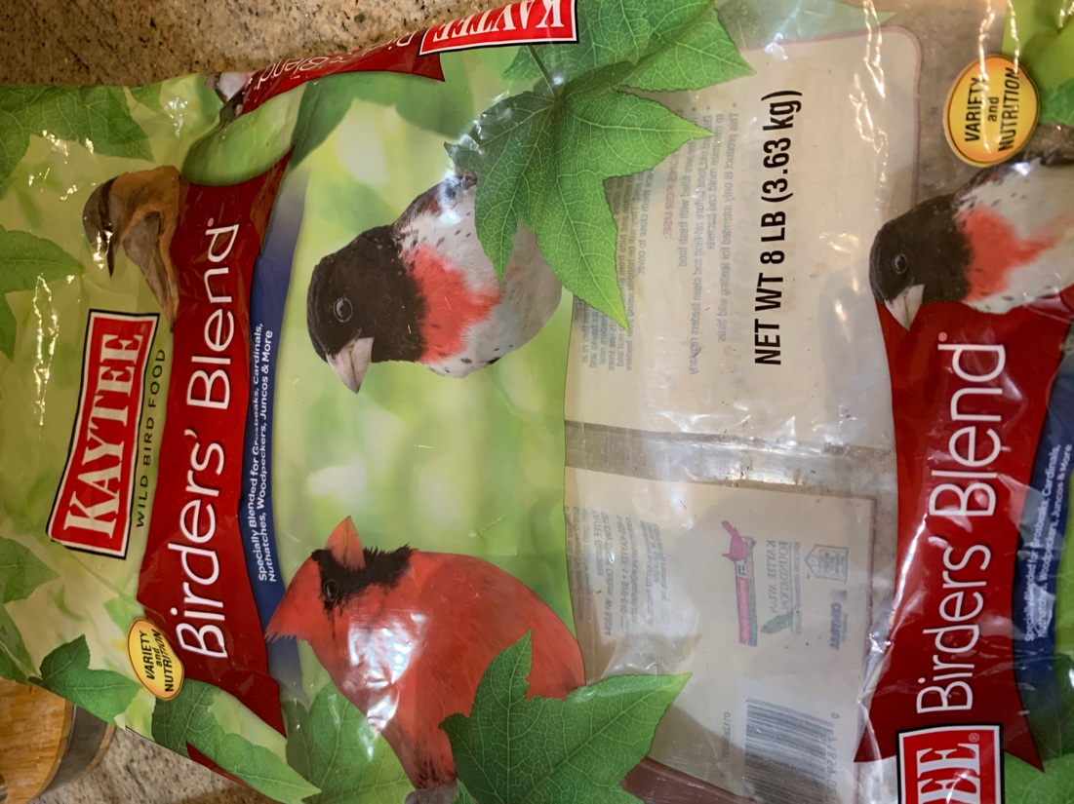

*Figure 4.* Bird seed used for the research study.

**Appendix B**

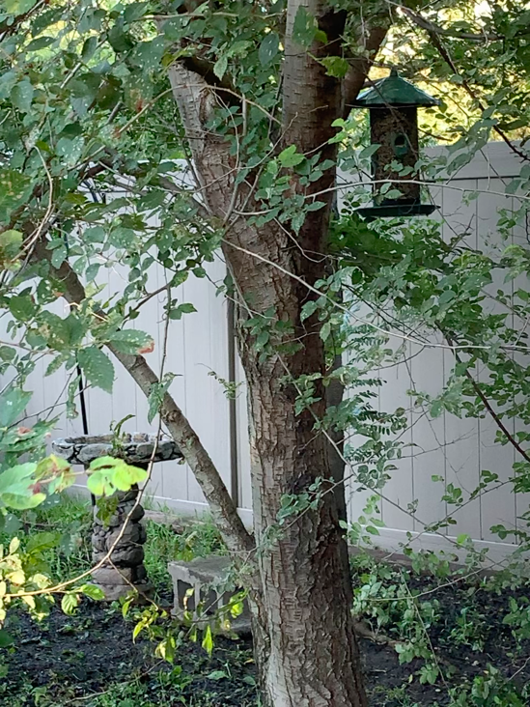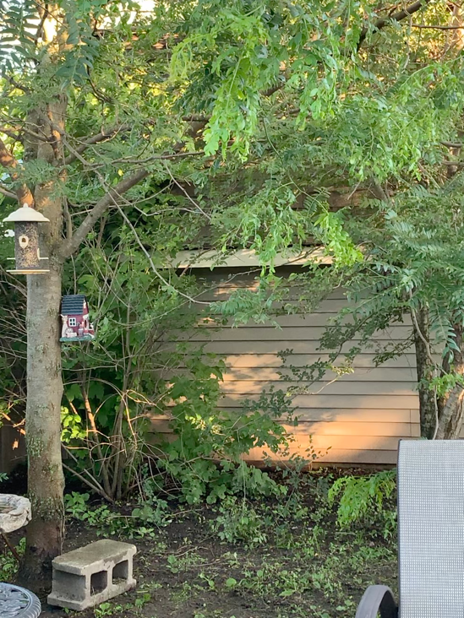

**Exhibit B**

**Exhibit A**

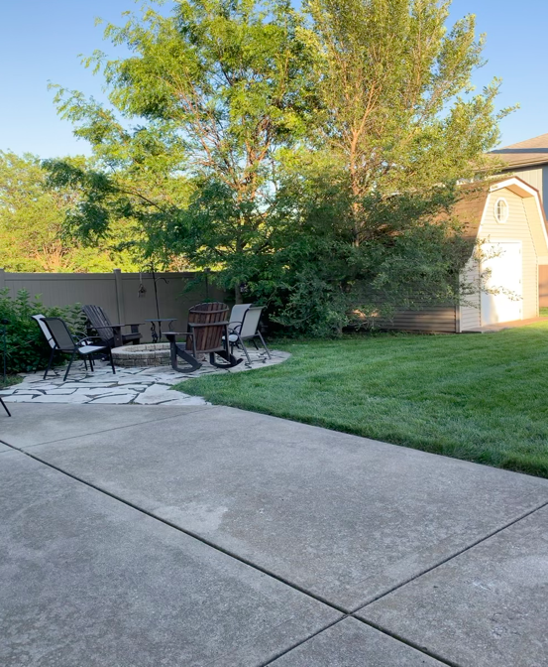

**Exhibit C**

*Figure 5.* Exhibit A shows the color of the yellow feeder and the setting of one location. Exhibit B shows the color of the green feeder and the setting of the second location. Exhibit C shows the distance of the feeders from housing.